**Assignment 5**

**Name: Udit Dhand (umd84), Sanyam Jain (sj33448)**

Duration: Self-paced, typically 3 hours

Link: https://kubernetes.io/docs/tutorials/stateless-application/hello-minikube/

Instructions:

1. Set up a local Kubernetes cluster using Minikube.

1. In the website's Tutorial tab, go through the 'Hello Minikube'

2. In the Tutorial tab's 'Learn Kubernetes Basics' go through the

A. 'Create a Cluster'

B. 'Deploy an App'

C. 'Explore your app'

D. 'Expose your App'

E. 'Scale your App'

2. Obtain screenshots showing that each step above is done, paste into a file and upload the file.

**Step 1 - local Kubernetes cluster using Minikube**

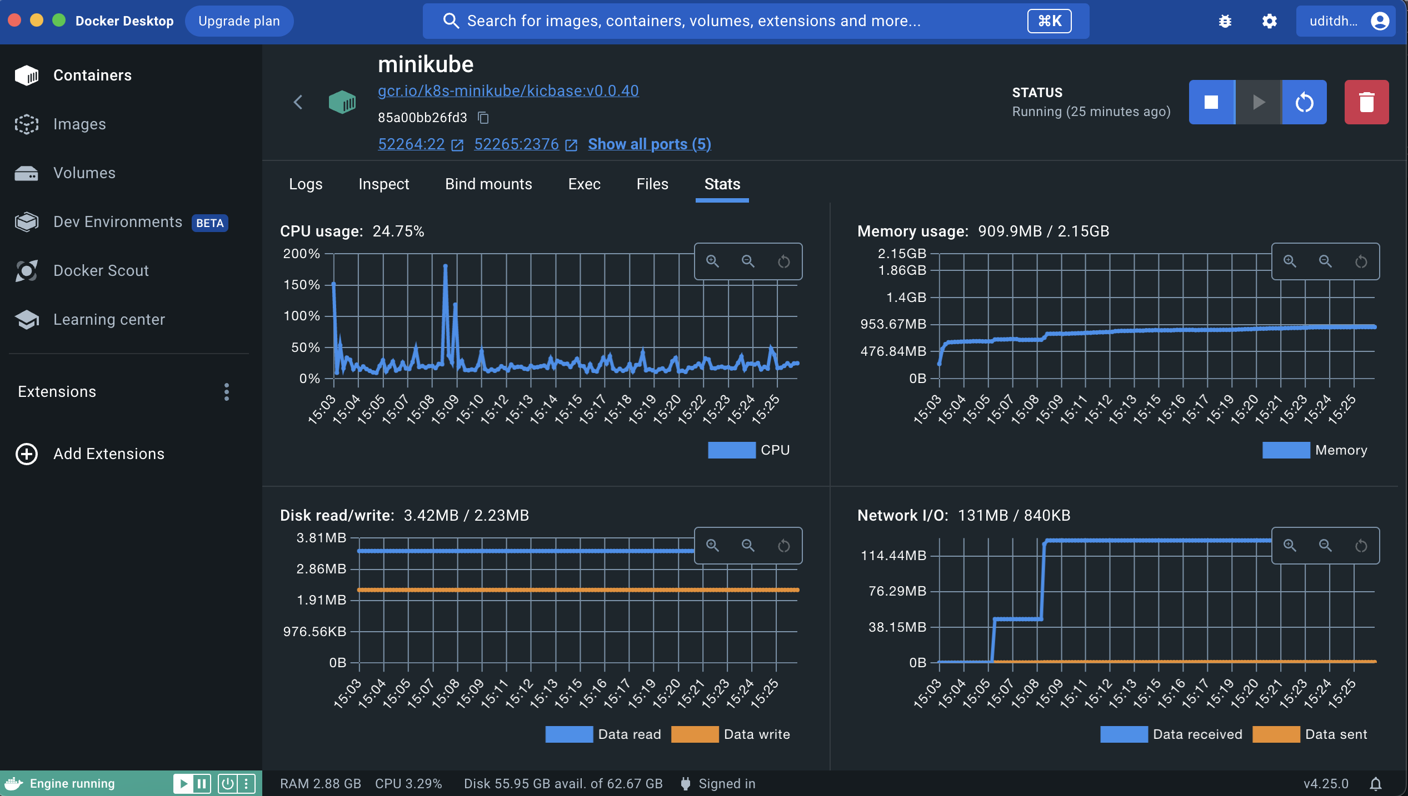

**Tutorial Step 1 – Create a cluster**

**Tutorial Step 2 – Deploy an App**



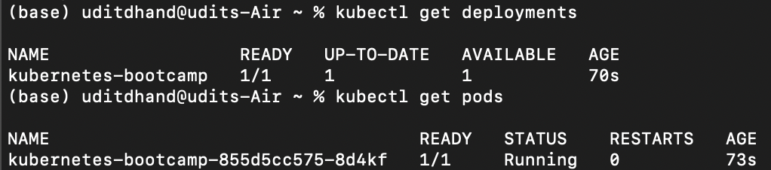

**Tutorial Step 3– Explore the App**

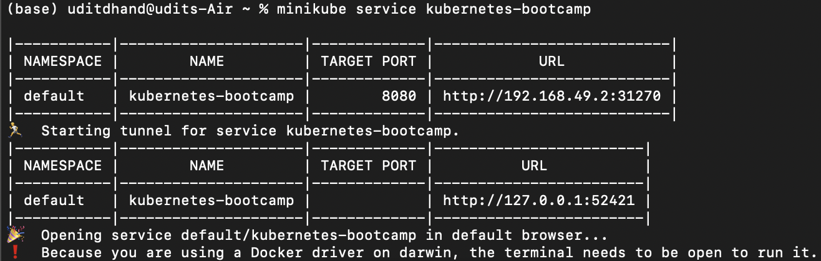

**Logs:**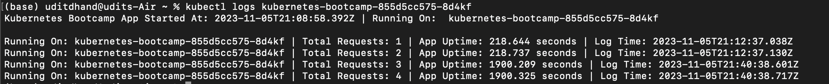

**Pod description:**

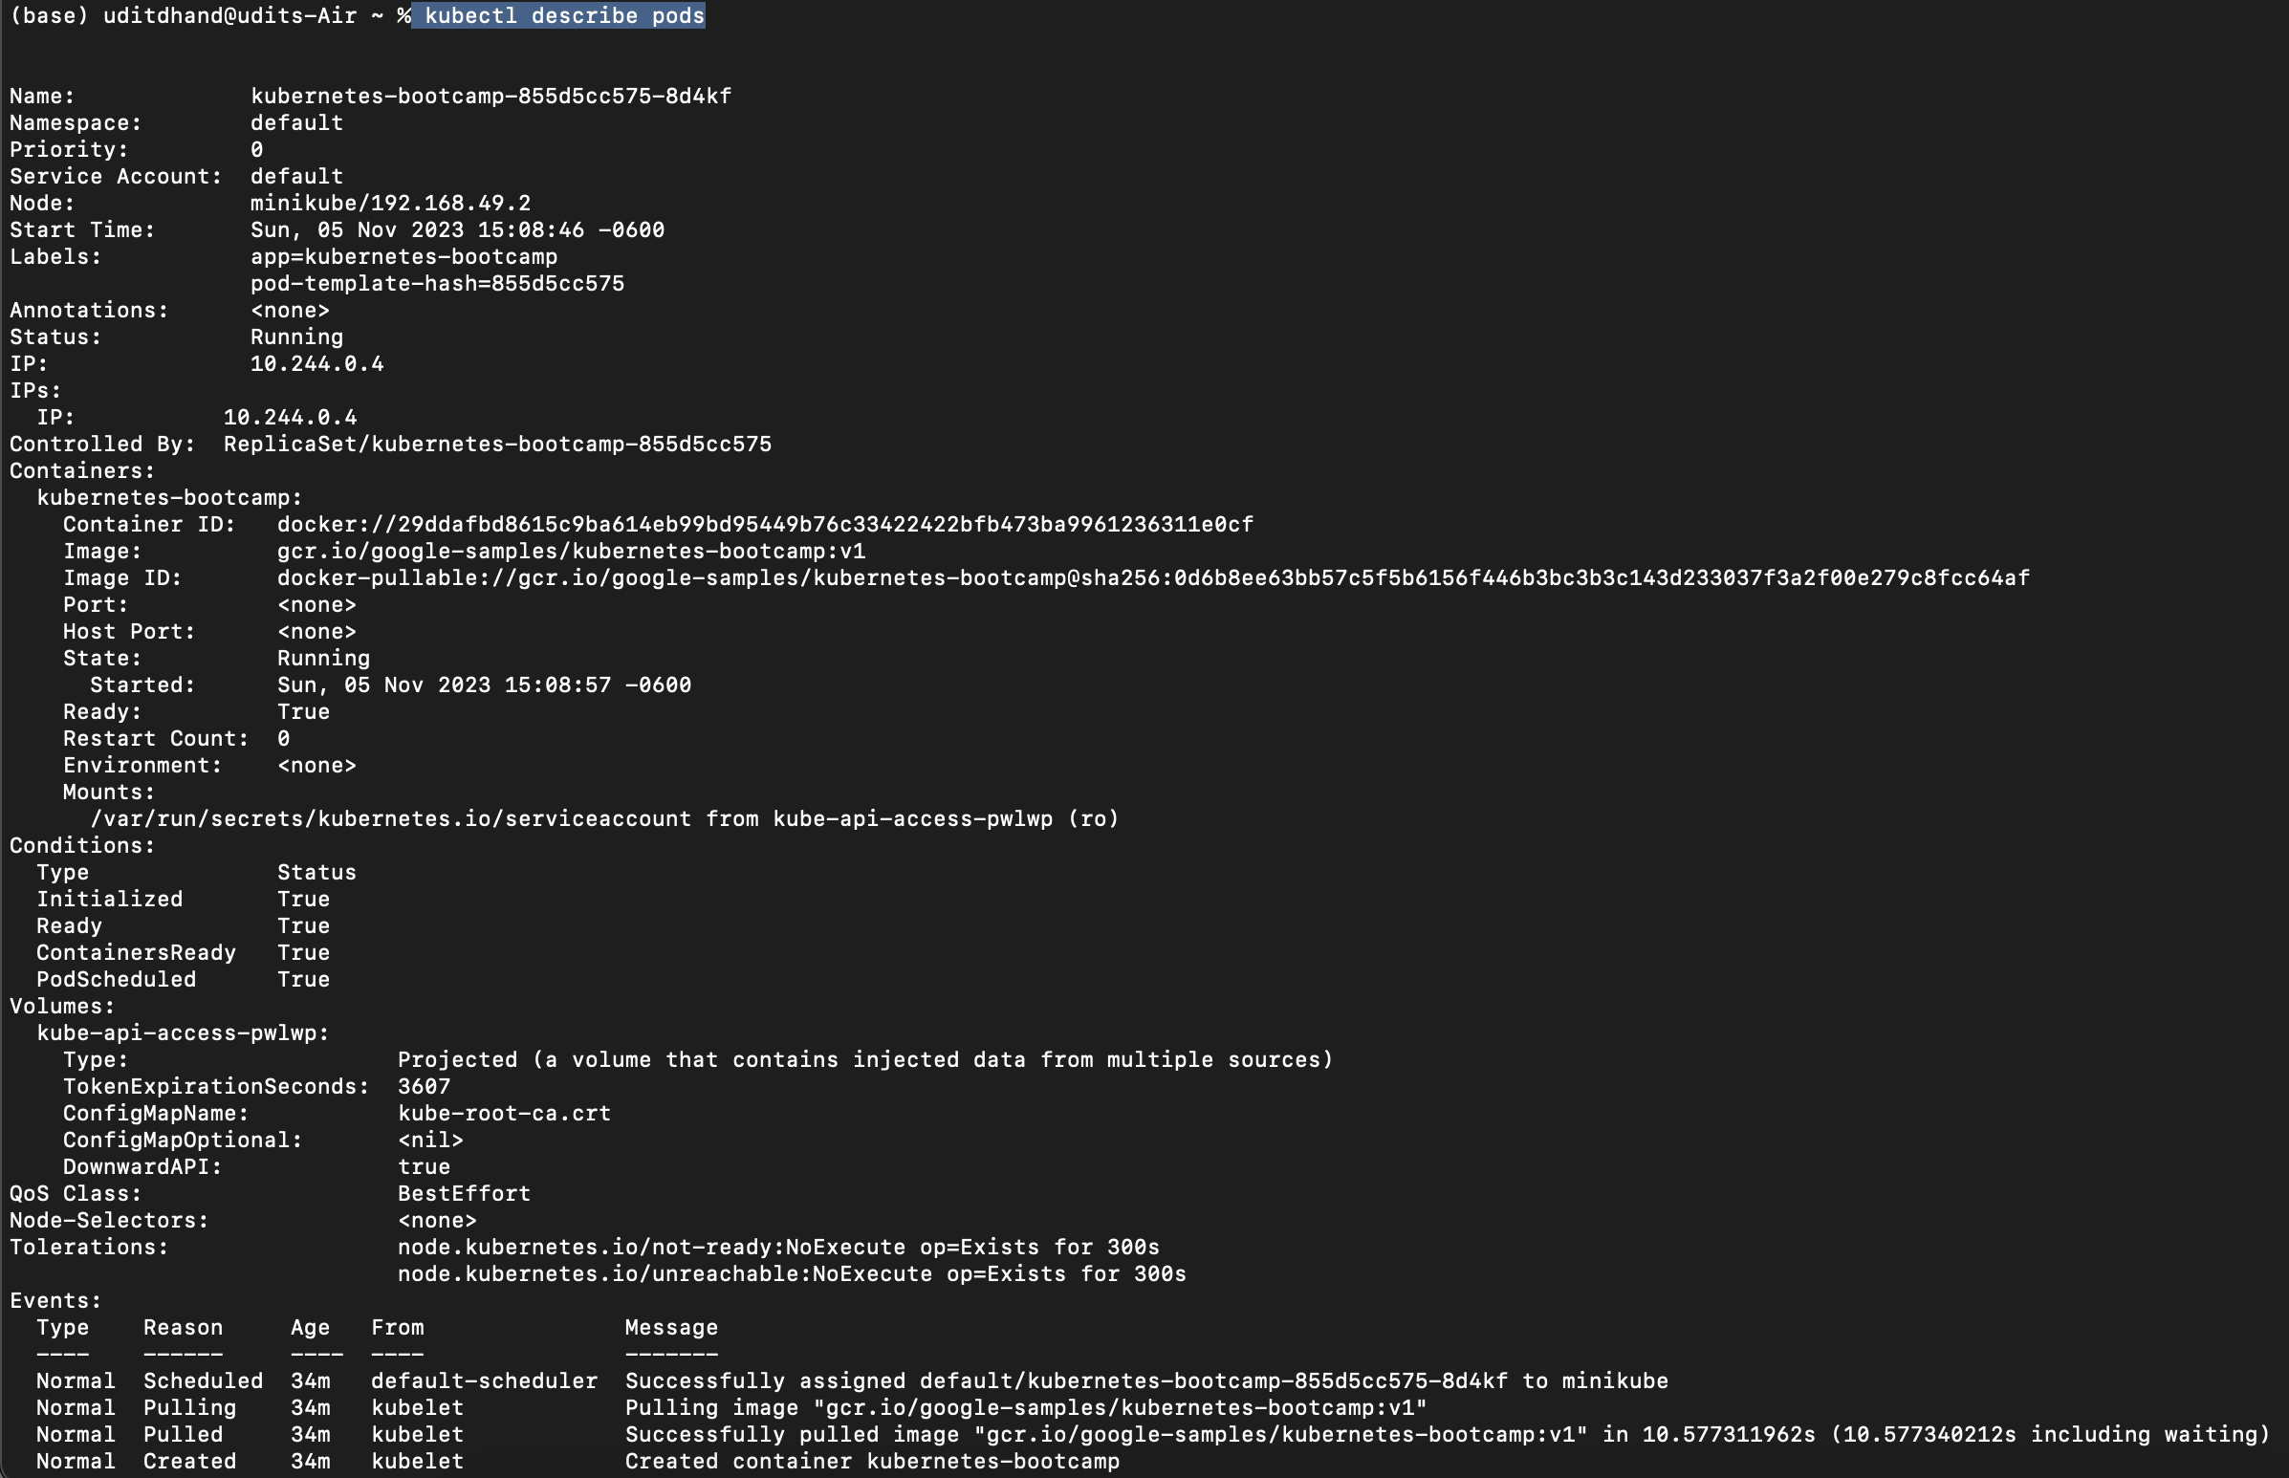

**Tutorial Step 4– Expose an App**



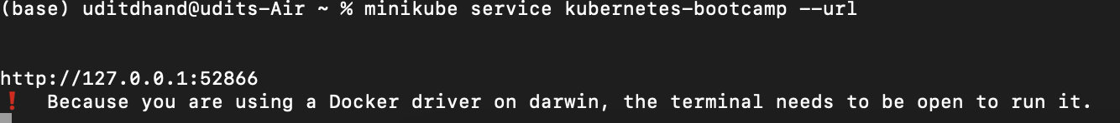



**Tutorial Step 5 – Scale an App**

**Each curl request is hitting different pod, meaning load balancer is working.**

